Student worksheet

2.1 Mixtures are a combination of two or more substances

Pages 30–31 and 174

Mixtures

Part 1 – In the mix

Having a ‘cuppa’ with a family member or a friend is a common occurrence across the households of Australia. However, most people probably do not consider the combination of substances that go into making a simple cup of tea.

1 This is a list of substances that make up a typical cup of tea: tea bag, milk, water, sugar, and a cup. Label the diagram below by stating in the boxes whether these substances are pure or a mixture.

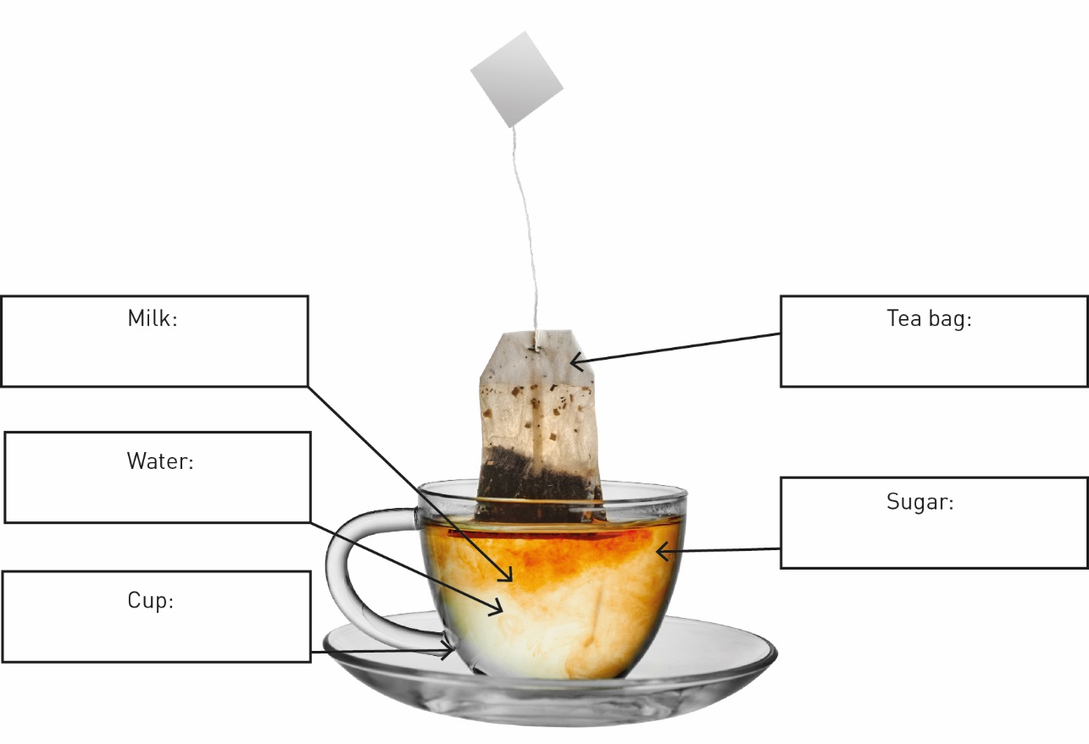

2 Is river water a pure substance? Why or why not?

Part 2 – The suspense is building

3 The diagram below shows how sea waves transport eroded materials and deposit these materials onto the beach.

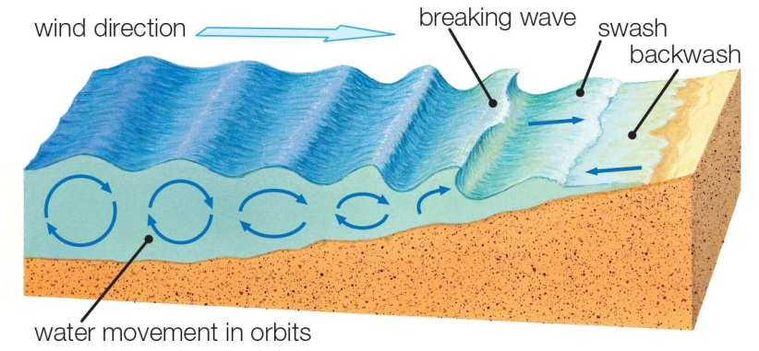

a What type of substances would be in solution in seawater?

b What substances would be in suspension in seawater?

c Think about a beach you have visited. What types of materials are deposited on the beach?

d

Imagine you took a jar full of seawater from the shore (the swash and backwash area). Draw a labelled diagram to show what the jar might look like before and then after the solid particles settled. Use the terms ‘suspension’ and ‘sediment’ in your labels.

|  |  |
| --- | --- |
| Before | After |

Part 3 – Let’s stick together

The word ‘colloid’ comes from the Greek word *kolla*, which means ‘glue’. This is an appropriate description of colloids because they are suspensions that do not separate easily.

4 Colloids and suspensions have similarities and differences. Some drinks (e.g. chocolate-flavoured milk) are a mixture of a colloid and a suspension.

a To make sure you get the full chocolate flavour, what do you have to do to chocolate-flavoured milk before you open the container to drink it?

b Do you need to do the same to a container of plain milk before opening it?

c The chocolate would be a s_____________________________________ before you shake the container, but a s_____________________________ after you shake the container. However, the milk would be a c______________________________ regardless of whether it was shaken or not. This is because milk is an e_______________________________ of different liquids.

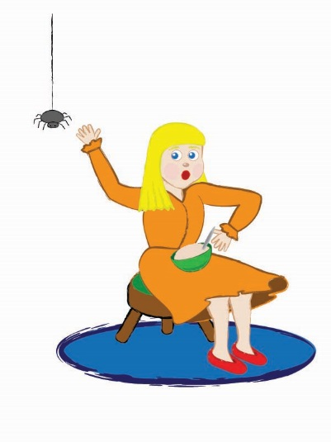EXTEND YOUR UNDERSTANDING

5 Use the Internet to research the science behind this old nursery rhyme:

*Little Miss Muffet*

*Sat on a tuffet,*

*Eating some curds and whey.*

*Along came a spider*

*Who sat down beside her,*

*And frightened Miss Muffet away.*

Little Miss Muffet was a small girl whose name was Patience Muffet. Her stepfather, Dr Muffet (1553–1604), was a famous entomologist who wrote the first scientific catalogue of British insects.

a What are curds and whey?

b How can the milk emulsion be separated into curds and whey?

Student worksheet

2.2 A solution is a solute dissolved in a solvent

Pages 32–33 and 175–176

Is there a solution?

1 Each of the foods and drinks listed below has been formed as a result of solubility. Name the main solute and the solvent in each.

|  |  |  |
| --- | --- | --- |
| Substance | Solute | Solvent |
| Hot chocolate |  |  |
| Black coffee |  |  |
| Instant gravy |  |  |
| Jelly |  |  |
| Soda (carbonated) water |  |  |

2 Solutions are generally see-through or transparent. Which of the foods or drinks listed above could be classified as solutions?

3 Look at the bottle and the jug below. Both have been filled with a blue solution, but one is more concentrated than the other.

a In the space provided, draw a diagram to represent the solute particles in both containers.

|  |  |
| --- | --- |
|  |  |

b Which container had the lowest concentration of the solute?

c What is the simplest way to make both the solutions in the containers more dilute?

4 Fish are a very common pet for children to have because they can be kept in a bedroom and are easy to look after…as long as you understand the importance of gases dissolved in liquids.

a Why is it important to have green plants or a bubbling filter in fish tanks?

b Could a fish survive in a tank full of pure water but nothing else?

EXTEND YOUR UNDERSTANDING

5 Water is the most common solvent but there are also other useful solvents. Research at home or on the Internet which solutes will dissolve in the solvents listed below.

|  |  |
| --- | --- |
| Solvent | Solutes that will dissolve in this solvent |
| Methylated spirits |  |
| Kerosene |  |
| Turpentine |  |
| Acetone |  |

Student worksheet

2.3 Mixtures can be separated according to their properties

Pages 34–35 and 177–178

Separate properties

1 Examine each of the images below. Name and explain the most effective method to separate the components of each of the mixtures according to their properties.

|  |  |
| --- | --- |
| a |  |
| b |  |
| c |  |

2 Your science teacher brings a large bucket to class. Inside the bucket is a mixture of the following: water, sand, iron nails and grass clippings floating on top. Your task is to separate the four components using four different methods of separation. Draw a simple diagram and write a brief description of the steps you would take in the flow chart below. Consider the order of the methods.

Bucket containing water, sand, iron nails and grass clippings.

EXTEND YOUR UNDERSTANDING

3 Research some of the methods that were used to clean up the Deepwater Horizon oil spill in the Gulf of Mexico in 2010.

Student worksheet

2.4 Mixtures can be separated according to their size and mass

Pages 36–37 and 179–180

Separating mixtures

Part 1 – Separation by filtration

1 Below are two different filters, a HEPA filter and a colander.

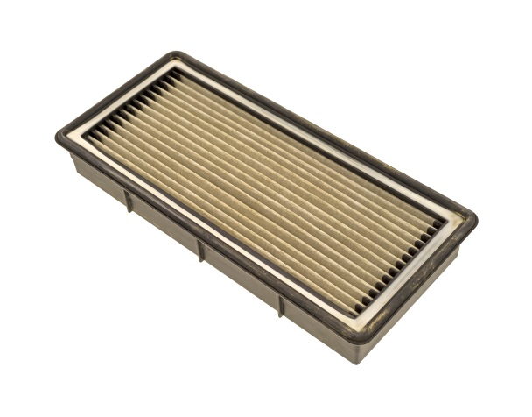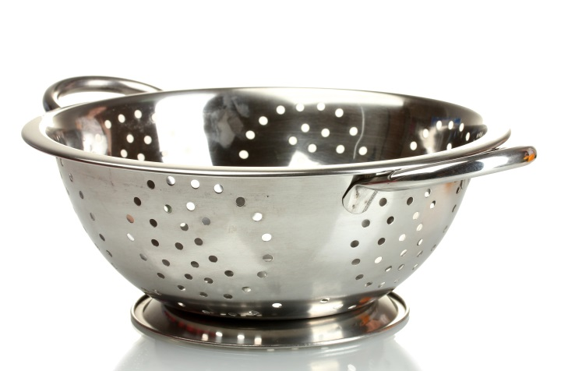

a Describe at least two features both filters have in common.

b Describe how these two filters are different.

2 Label the diagram using the following words: funnel, filter paper, residue, filtrate

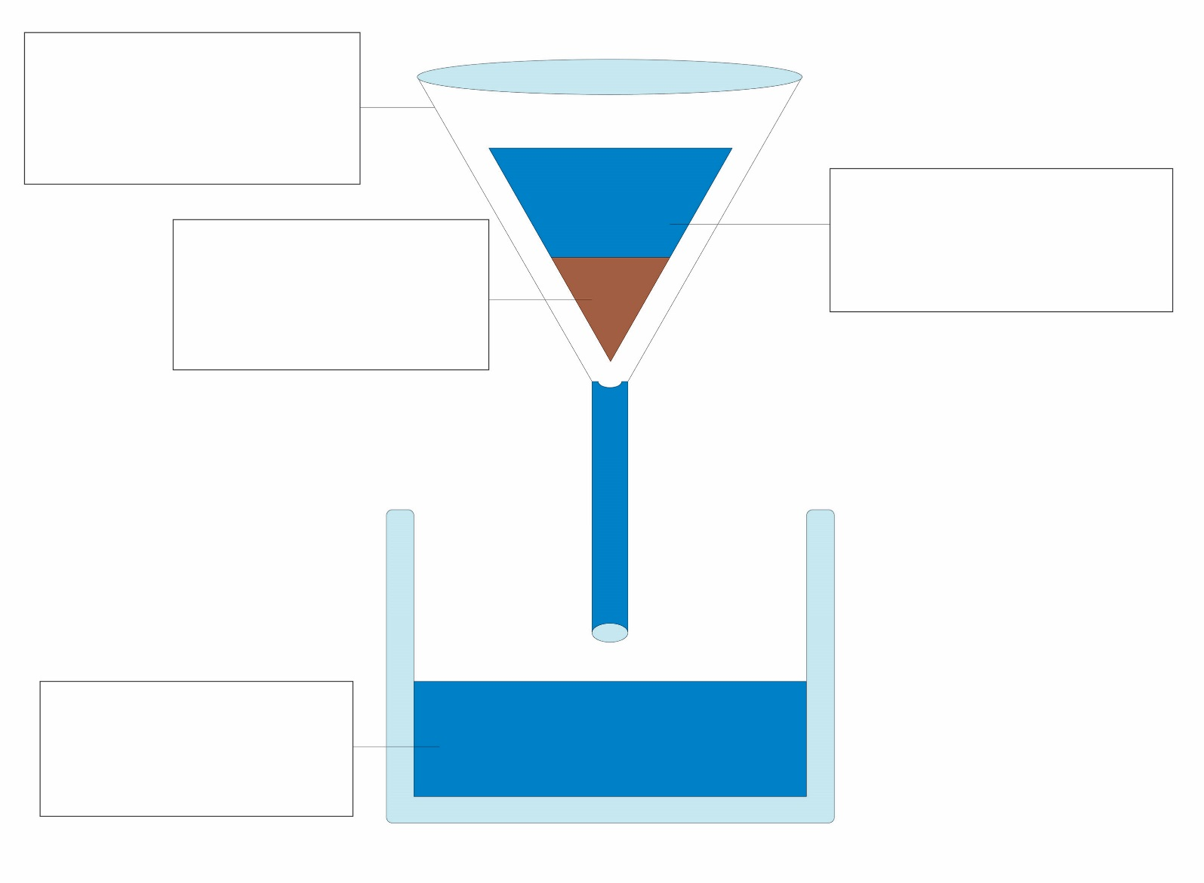

a Name three mixtures that could be separated using this method

b Identify at least five different filters that are present in your home.

Part 2 – A spin on separation

3 A test tube of blood is spun in a centrifuge to separate it into its components.

a How is the blood separated in the centrifuge?

b Why does blood separate in the centrifuge in this way?

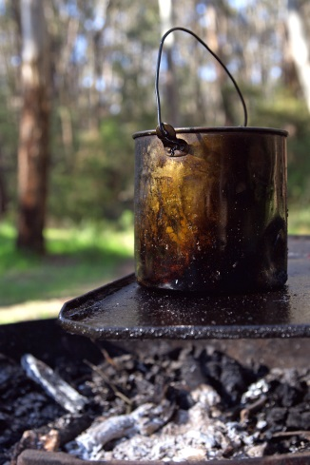

4 If you have ever been camping you may have made ‘billy tea’. The tea leaves and water are put into the billy, which is placed on the fire. Once the water has boiled, the billy is picked up and swung around in a large circle.

a Why do you think the billy is swung around in a large circle?

b What method of separation would be used to pour the drinkable tea out of the billy but leaving the tea leaves behind?

EXTEND YOUR UNDERSTANDING

5 Find out how centrifuges are used in the production of dairy products such as cream.

Student worksheet

2.5 The boiling points of liquids can be used to separate mixtures

Pages 38–39 and 180–181

Going off the boil

1 Imagine you made a cup of tea at home for a friend and accidentally put in sugar. Instead of making a new cup of tea, you decided to use your knowledge of science to separate this mixture. So you decide to pour the cup of tea into a saucepan and put it on the stove.

a What method of separation are you using?

b What crystals would remain in the saucepan?

c What would happen to the liquid tea?

d Would it have been better to make another cup of tea for your friend?

2 The table below shows the boiling points of common liquids.

a Use the data to create a column graph ranging from the lowest to the highest boiling point in the space provided.

|  |  |
| --- | --- |
| Liquid | Boiling point (°C) |
| Water | 100 |
| Alcohol | 78 |
| Petrol | 95 |
| Olive oil | 300 |
| Tar | 300 |
| Turpentine | 160 |

b What would be some safety concerns if you tried to separate a mixture of all of these commons liquids at home?

3 The equipment used for distillation in the science laboratory involves a number of different apparatus. On the diagram below, label the equipment.

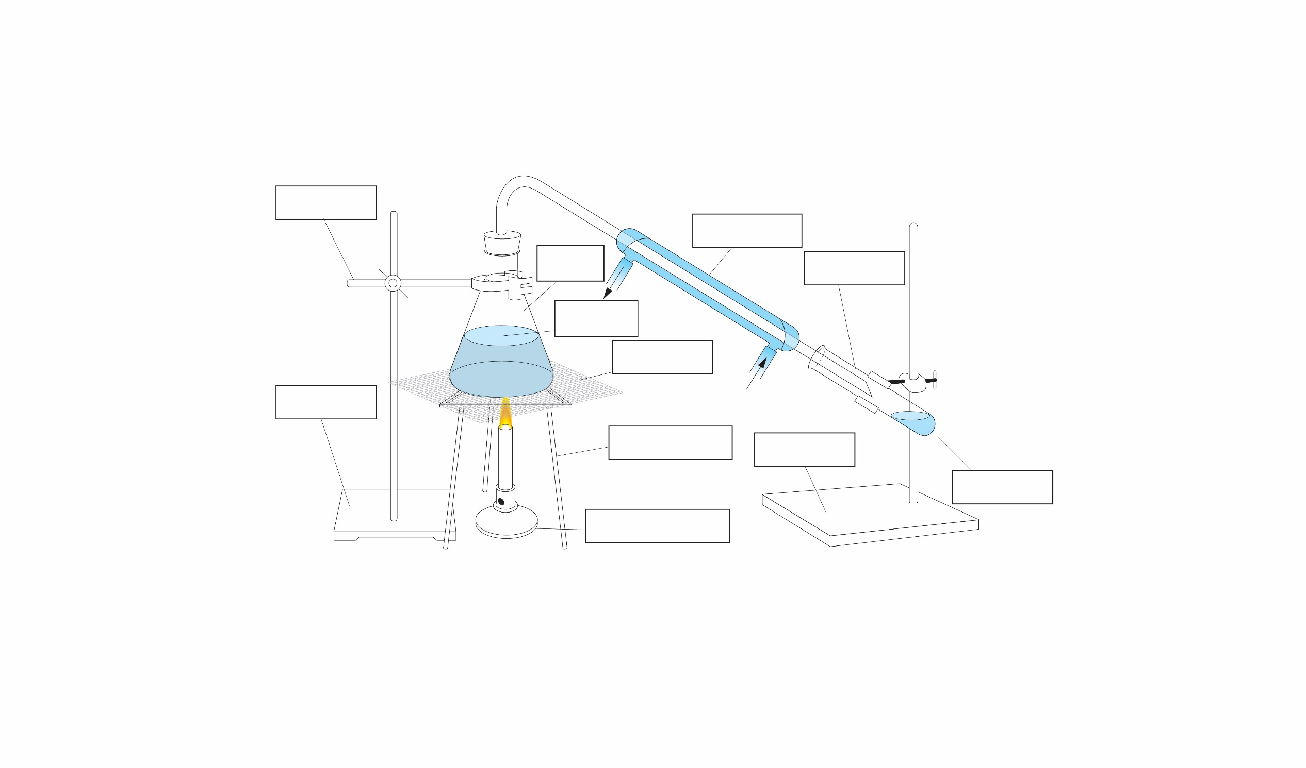

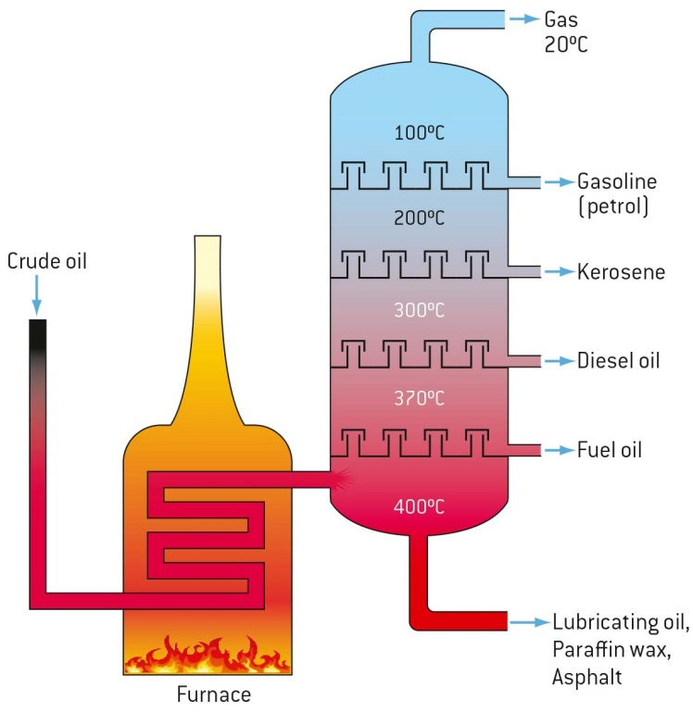EXTEND YOUR UNDERSTANDING

4 Examine the diagram to the right, which shows the various products that can be separated from crude oil in the process of fractional distillation. Research one use of the products extracted from crude oil.

a Gas: __________________________________

b Petrol: _________________________________

c Kerosene: ______________________________

d Diesel oil: _______________________________

e Fuel oil: ________________________________

Student worksheet

2.6 Solubility can be used to separate mixtures

Pages 40–41 and 182–183

A mixture to dye for

As you have discovered through your investigation of paper chromatography, the coloured dye that is most soluble is at the top of the paper and the least soluble is at the bottom. You may also have noticed that the solvent you use will eventually move the furthest, almost all the way to the very top of the paper.

A simple calculation can be used to work out the Rf value, or retention factor, which is the distance travelled up the paper by a colour divided by the distance travelled up the paper by the solvent.

In the diagram below, paper chromatography has been used to separate black ink into purple, orange and blue dyes. Use the diagram to work out the Rf value of various colours in the paper chromatography sample. The equation to use is:

Rf = distance travelled of the colour ÷ distance travelled by the solvent.

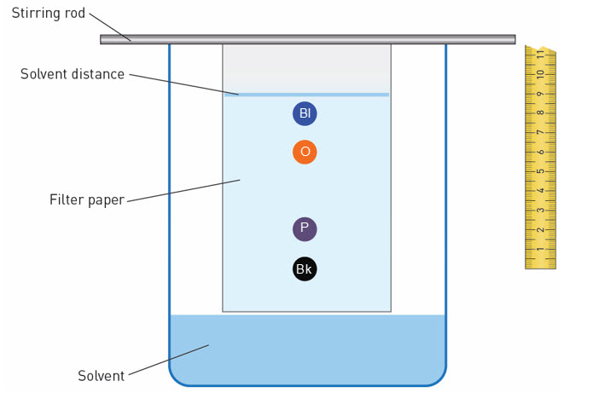

1 What is the Rf value of:

a purple?

b orange?

c blue?

EXTEND YOUR UNDERSTANDING

2 Calculate the Rf value of the colours in Experiment 2.6 ‘Who wrote the nasty note’, on page 182 of the textbook.

Student worksheet

2.7 Science as a human endeavour: Waste water is a mixture that can be separated

Pages 42–43

What a waste

1 Use the information from pages 42–43 to answer the questions surrounding the diagram below.

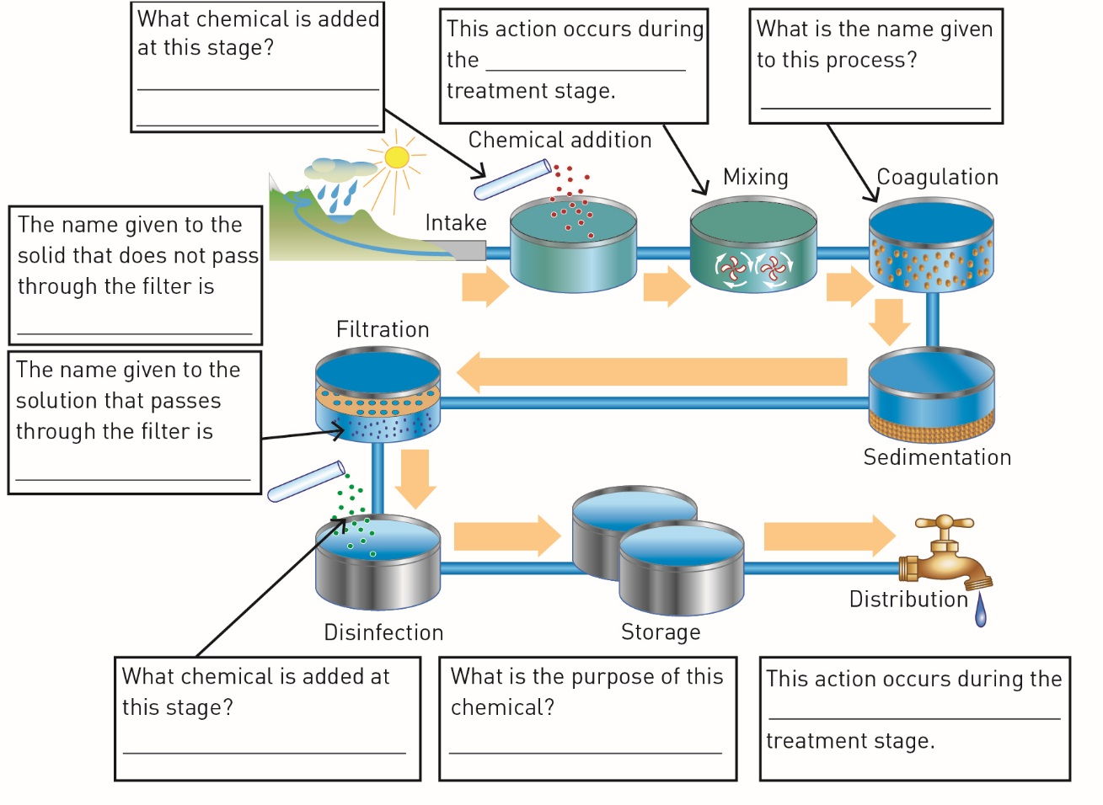

2 The diagram on the right shows the primary stage in further detail.

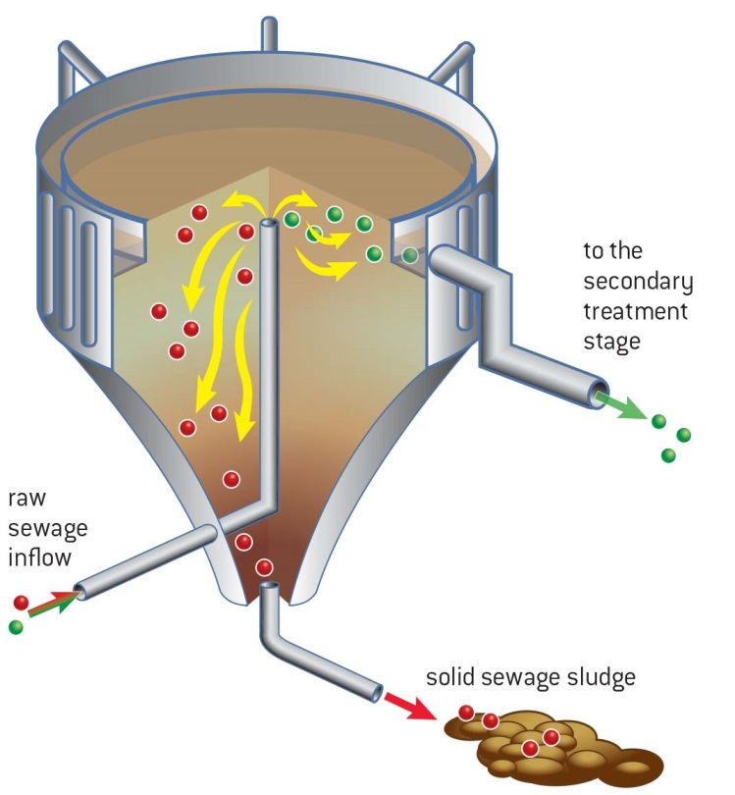a What type of mixture is the raw sewage inflow?

b What separation process has caused the solid sewage sludge to form?

c How has aluminium sulfate been used in this process?

EXTEND YOUR UNDERSTANDING

3 Try to work out the answer to the following question:

In the lake pictured, there is an algal bloom. Every day, the algal bloom doubles in size. If it takes 34 days for the algal bloom to cover the entire lake, how long did it take for the algal bloom to cover half the lake?

